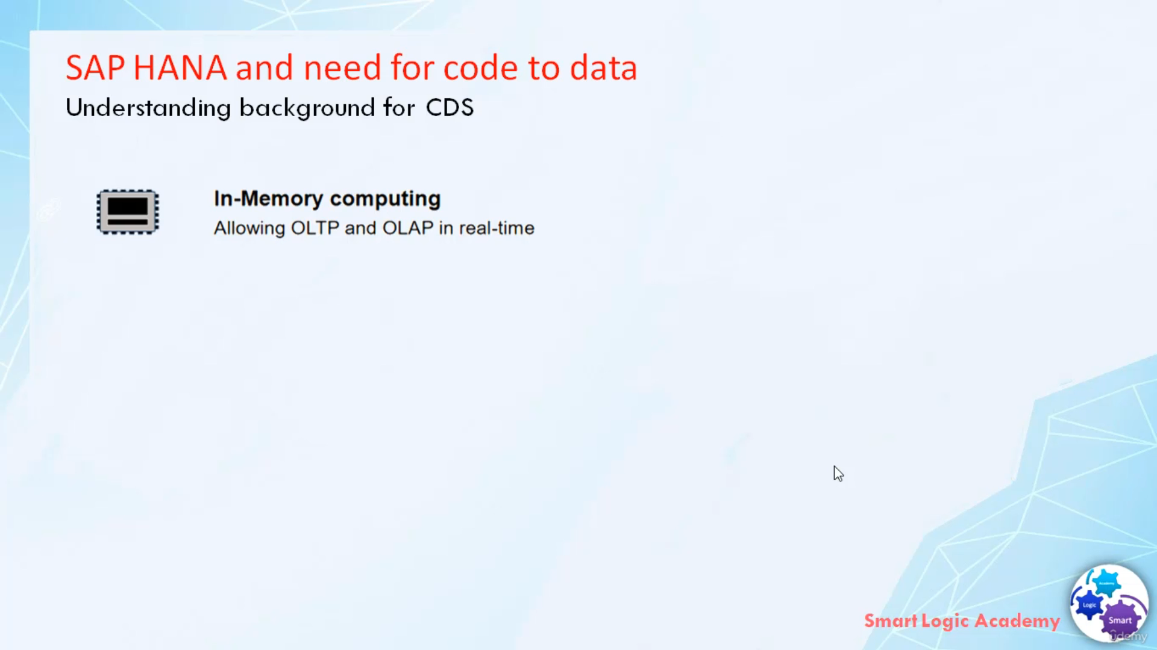

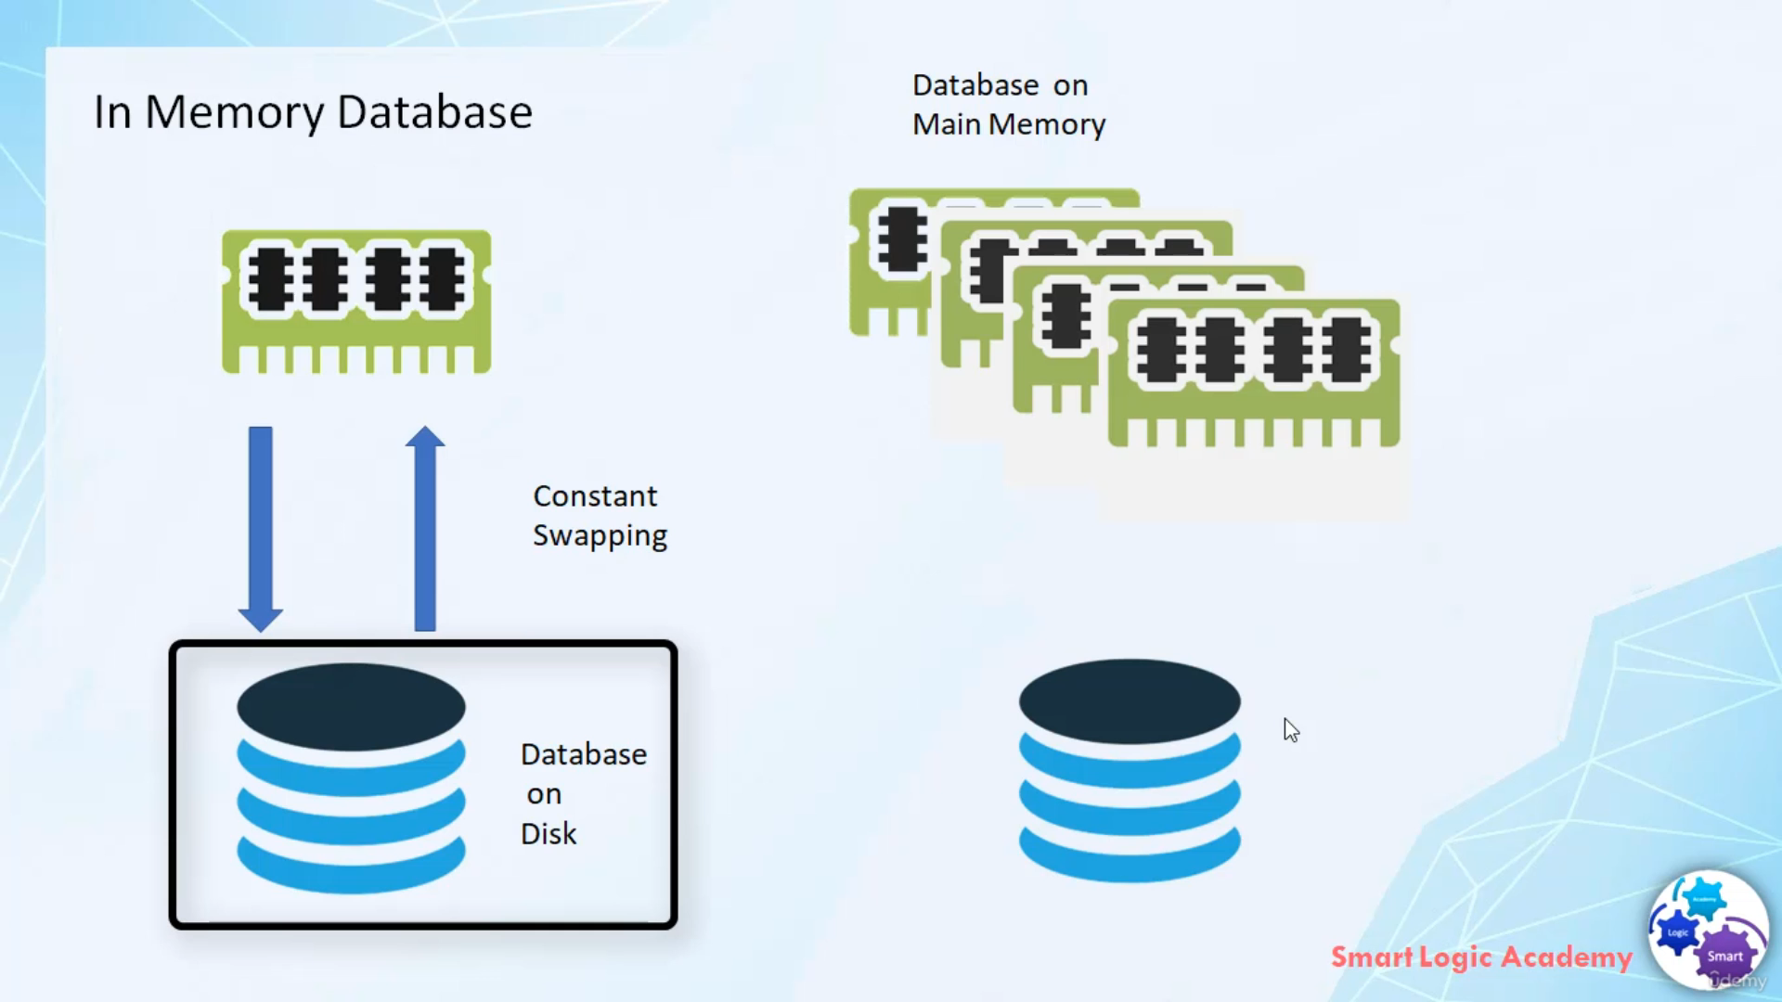

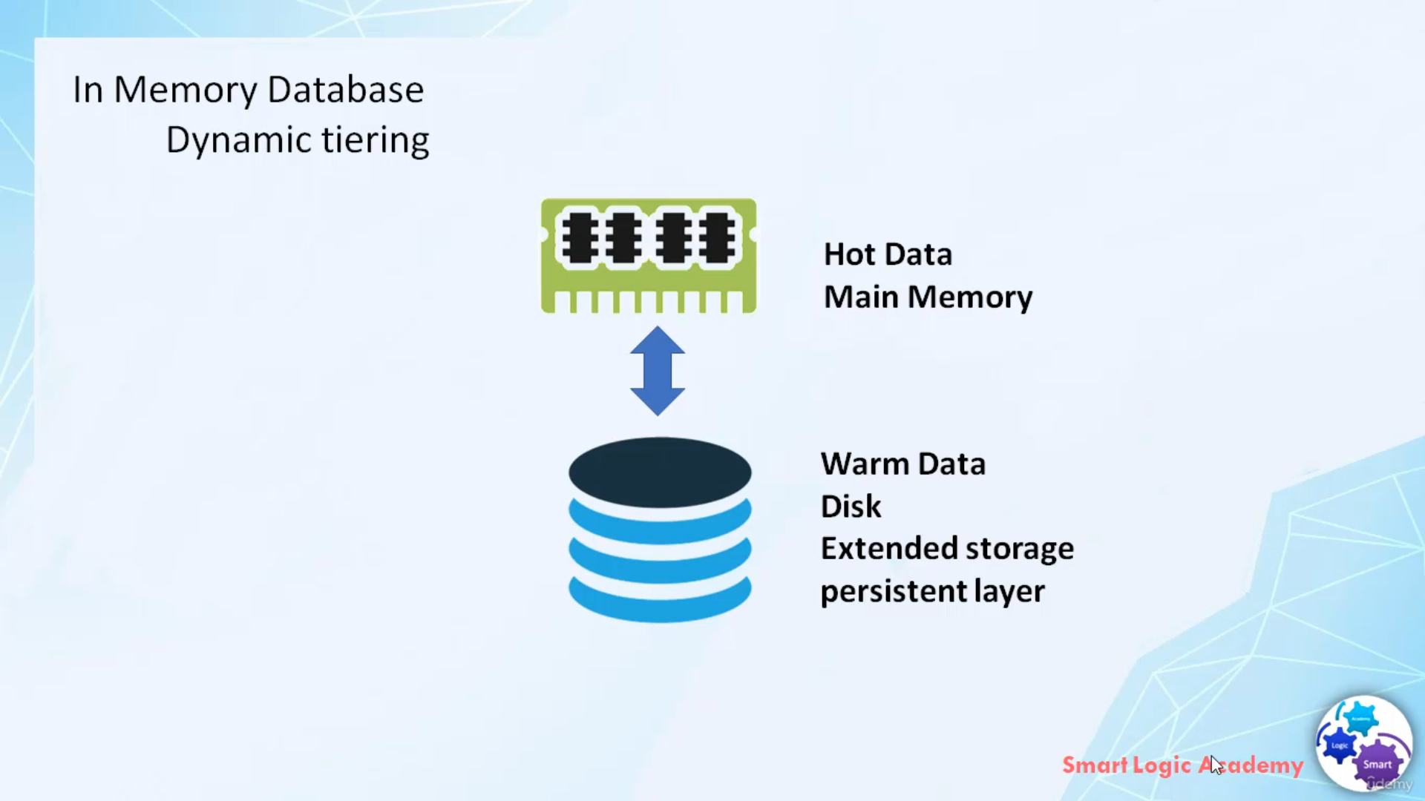

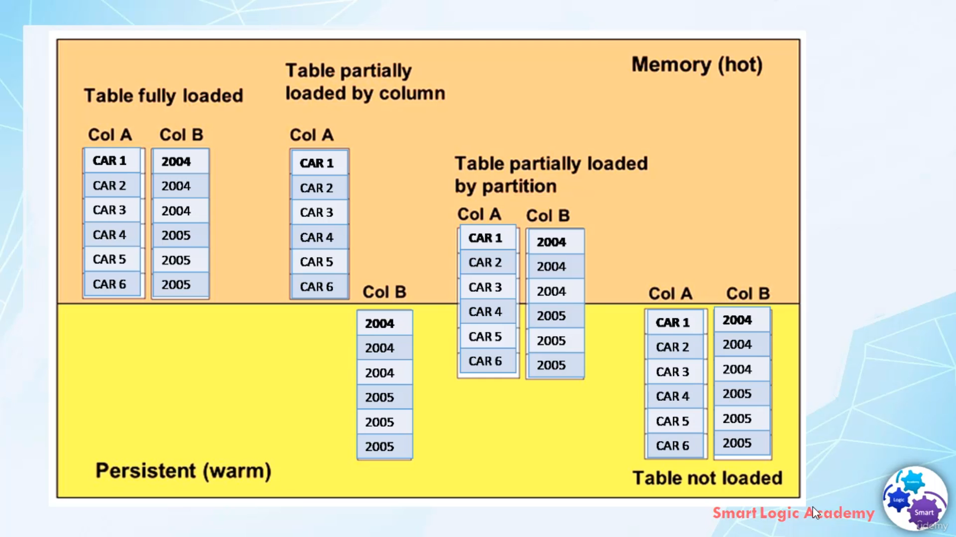

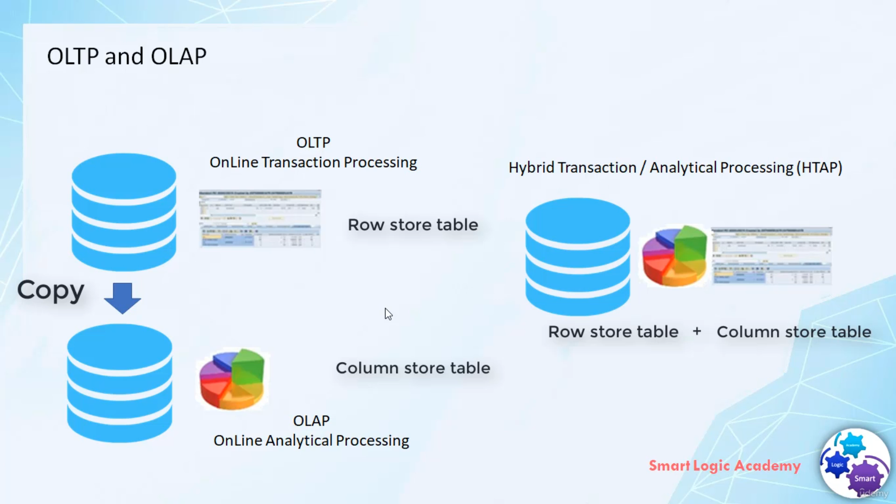

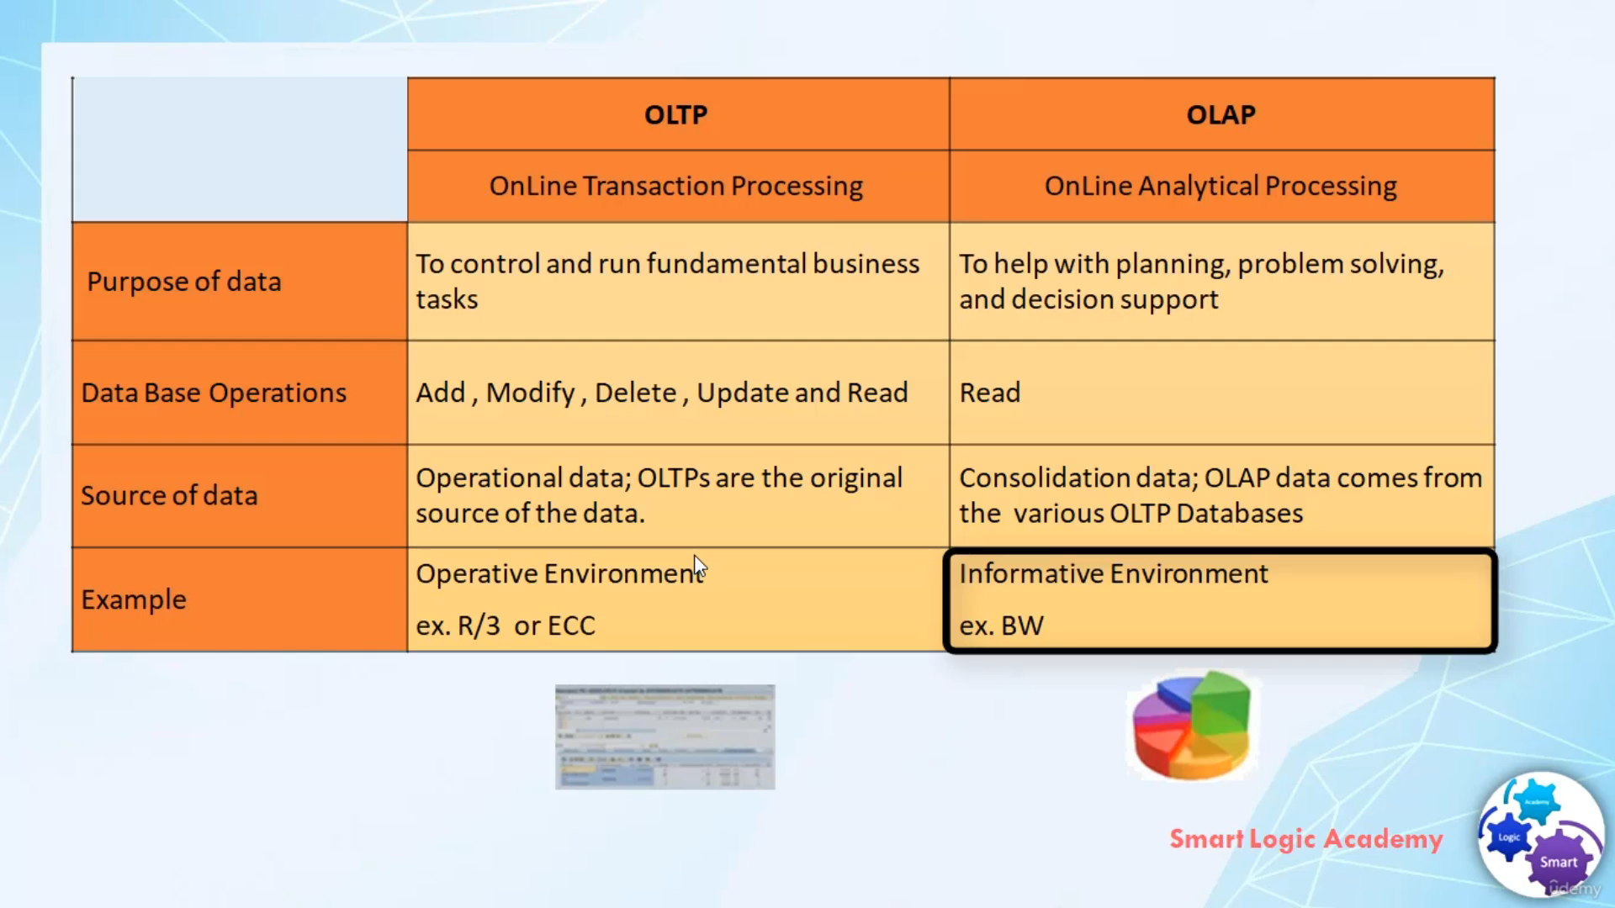

The main feature of SAP HANA is, it's an in-memory database and it allows OLTP and OLAP in

real time.

In the past database were stored completely on disk. Only the data requested by applications will be moved to memory then it passes to CPU for processing. Data in memory would be constantly displaced with new data request.

so, a lot of swapping was normal. Conventional database systems were designed to perform well on computer system with limited RAM and that's why slow disk input-output was the main bottleneck in data throughput. With SAP HANA you can now store a complete database in memory.

This means that the disk movement is not needed, and swapping can be eliminated hence increase in the speed of read and write access.

Storing data in main memory rather than disk provide faster data access and by extension faster querying and processing. While storing the data in the main memory grants performance advantage.

It is more costly from a data storage point of view. Observing the data access pattern, up to 85 percent of data in the enterprise system may be infrequently accessed, therefore it can be more effective to store more frequently accessed data in SAP term HOT data in main memory, while the less frequently access data in SAP term WARM data in do disk.

This approach SAP has termed as dynamic tiering.

SAP HANA is often described as in-memory database although this is true, SAP HANA has a persistent storage layer too. The persistent storage layer.

here, is disk-based and it's a mandatory part of SAP HANA and it's not a separate component.

Why we required disk base memory?

The first reason is to provide an area to unload less important data when the main memory is full and the second reason is to enable data recovery if there is any power failure.

Any data that can be accessed by any application always come from main memory.

This means that if the table is sitting in the persistent layer, the moment it is needed the table is automatically loaded to the main memory and it becomes HOT data. SAP HANA handles the conversion of WARM data into HOT data very intelligently.

Column tables can also be partitioned and SAP HANA can load only the required columns and partitions to the main memory. This is advantageous because it helps to leave the unwanted columns and partition in the persistent layer.

Now I hope you understood what is an in-memory database, what is dynamic dieting and what is HOT data and WARM data.

Now let's see what is OLTP and OLAP

OLTP stands for online transaction processing and OLAP stands for online analytical processing.

Traditionally systems were either optimize for the transaction or for analysis.

In most of the traditional relational database, tables are ROW based as this is regarded as the optimal

design for transaction system, but for analytics COLUMN tables are more optimal.

Now you must be wondering what is this transaction applications and analytic applications.

So let's put more light on this

two terms. Transitional applications are a type of information system that collects, stores, modify

and retrieve the data transmissions of an enterprise.

Mostly such kind of applications use database operations like read, insert, update, modify and delete

whereas analytical applications are their business applications software that are used to measure and

improve the performance of business operations.

Mostly such that kind of application use READ database operation.

SAP HANA database supports both ROW tables and COLUMN tables. ROW tables and COLUMN tables

are storage types of a table that decides how the two-dimensional tables get stored into the database either

ROW wise or COLUMN wise. Both table storage types are needed in the platform that handles transactional

and analytic applications in the same database.

SAP HANA is a platform that simplifies IT landscape and removes the complexity that was developed over

many years.

The key object of SAP HANA is to remove all the residencies.

means that only one copy of data is needed for any type of access.

The traditional systems were either optimized for transactions are for analysis. OLTP systems use for

transactions and OLAP used for analytics.

Let's see, what is the difference between OLTP and OLAP.

The main purpose for OLTP is to control and run a fundamental business task.

Whereas the basic purpose of OLAP is to help with planning, problem solving and decision support.

basically for analytical processing. OLTP support database operations like add, modify, delete, update

and read whereas OLAP support mostly support database operation

Read.

for OLTP we use operational data, OLTPs are the orignal source of data in this case. Whereas in OLAP

we use consolidation data. OLAP data comes from the various OLTP database, so actually

OLAP data is nothing but the copy of OLTP data.

Example For OLTP is

R/3 or ECC systems.

Whereas the example for OLAP is BW business warehouse and because of the difference between

OLTP and OLAP processing, OLTP and OLAP were separated and linked through interfaces.

Now SAP HANA is able to bring transactional and the analysis requirements into one platform.

The acronym for this type of consolidated system is HYBRID transaction and analytical processing

HTAP

.

That's it for now.

I hope you have understood the theory.

Have a nice day.